
University of California, San Diego
ECE 164 – Analog Integrated Circuit Design
Project Report – Fall 2025
Huayu Zhang
PID: A69040187
Email: huz028@ucsd.edu
Futong Yang
PID: A69039862
Email: fuy003@ucsd.edu

Outline of Design
1. Design Methodology
This project employs the g_{m}/I_{D} methodology for core circuit size design. This method avoids the inaccuracies of traditional square-law formulas in short-channel technology (0.18µm) and achieves precise control over power consumption, bandwidth, and stability.
In general, we divided the entire circuit into a bias circuit and an amplifier circuit, with two team members each responsible for one. Huayu Zhang was responsible for the amplifier circuit design, and Futong Yang for the bias circuit design. The g_{m}/I_{D} method played a significant role in the amplifier circuit design. We first decomposed the amplifier section into independent modules based on the function of each transistor, and then performed small signal analysis. Based on the calculation results, we could determine which parameters in the circuit directly affected various performance aspects. Using a lookup table, we could calculate the preliminary size of each transistor and estimate the required bias voltage for each node based on the project specifications. After performance testing of the amplifier circuit, the bias circuit could be designed accordingly.
For the bias circuit, first we used the ideal voltage source to bias the amplifying stages, after determining the exact DC operating points, magic battery is used to generate the same and precise gate voltage for them, which is less affected by PVT variation, only by adjusting the amounts of transistors working in triode region (or ratio k). For constant-g_{m} circuit, the PMOS constant-g_{m} bias circuit generates g_{m} for PMOS differential input (same length L = 0.5μm), minimizes power consumption by current scaling, and is less affected by PVT variation. The bias core generates I_{ref} by scaling mismatch ratio K between PMOS transistors M_{b1} and M_{b2}. This size difference forces a specific ΔV_{GS} across R_{bias} to set the reference current. Finally, adjust R_{bias} to control all current branches.
2. Power Optimization Strategy: Current Scaling
To minimize power dissipation while maintaining enough bandwidth and gain, we implemented a current scaling method. Instead of generating the full operating current within the bias circuit, we designed the Constant-gm reference core to operate at a very low current level of 11.3µA. This low-power reference is then mirrored to the main amplifier stages using precise ratios (scaling the MOSFET widths, W).
By decoupling the reference generation from the signal amplification, we ensured that most of the power budget is allocated to the signal path (Input Pair, Folded Cascode and Output Stage) to maximize transconductance gm, rather than being wasted in the static bias branches. This approach allowed us to achieve a total power consumption of 1.18 mW, well below the 2.5mW specification. Next, we will explain how we manually calculated and made minor adjustments to each part of the circuit and finally compare the results of the manual calculations and simulations.

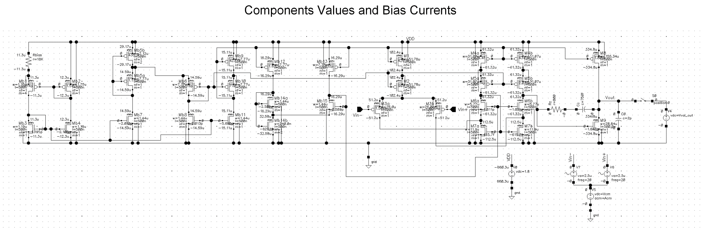
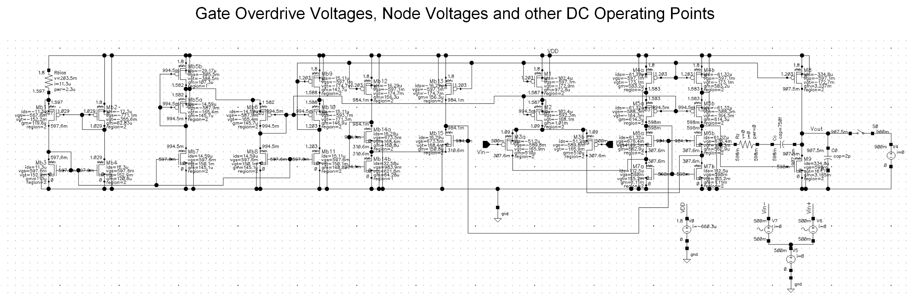

Key Design Parameters Calculations
1. Hand Calculations
1.1 Two-stage amplifier circuit
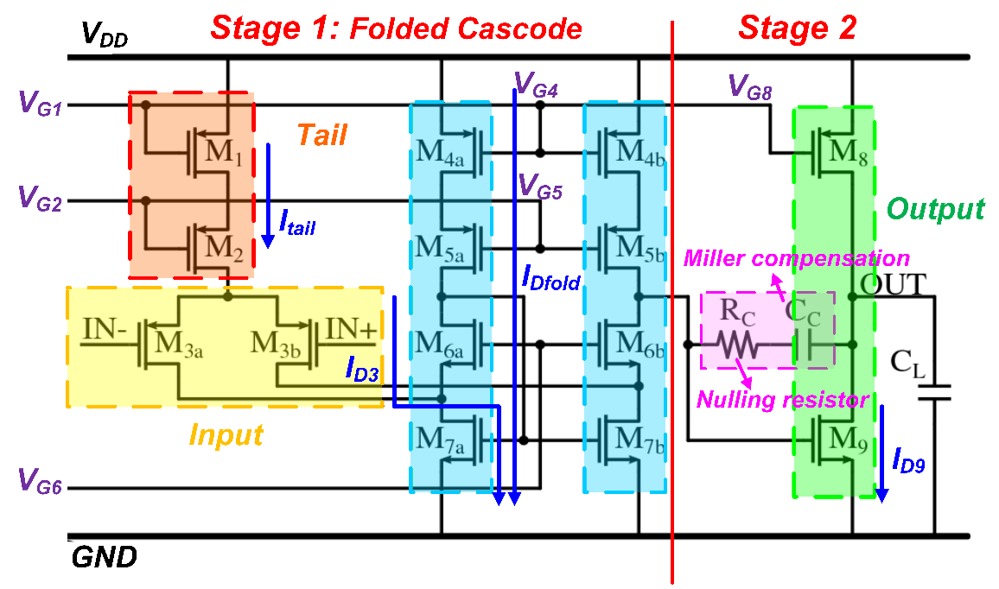
1.1.1 Small-signal gain analysis
First, we analyze Stage 1. With its half-circuit model, we can approximately get:
A_{v1} = −G_{m1} × R_{o1} = − g_{m3} × (R_{up} || R_{down})
R_{up} ≈ g_{m6} r_{o6} (r_{o7} || r_{o3}) R_{down} ≈ g_{m5} r_{o5} r_{o4}
Similarly, for Stage 2:
A_{v2} = −G_{m2} × R_{o2} = − g_{m9} × (r_{o8} || r_{o9})
Therefore, the total gain:
A_{vtot} = A_{v1} × A_{v2} = g_{m3} [ (g_{m6} r_{o6} (r_{o7} || r_{o3})) || (g_{m5} r_{o5} r_{o4}) ] ∙ [ g_{m9} × (r_{o8} || r_{o9}) ]
To achieve a gain >70dB, experience suggests that Stage 1 typically provides high gain (50~70dB), while Stage 2 provides moderate gain (20~40dB).
1.1.2 Frequency response and poles & zeros
The parameters calculated in this part are crucial for satisfying UGBW and phase margin requirements. The dominant pole is located at the gate of M₉:
ω_{p1} ≈ −1 / R_{o1} R_{o2} G_{m2} C_{C}
with this equation, we can get the equation of UGBW:
UGBW ≈ A_{vtot} × ω_{p1} = G_{m1} / C_{c} = g_{m3} / C_{C}
To meet UGBW ≥ 80MHz, we can easily calculate the range of g_{m3} / C_{C}.
The secondary dominant pole is located at Vout, it determines the Phase Margin:
ω_{p2} ≈ −G_{m2} / C_{L} (1 + C_{par1} / C_{C}) ≈ − g_{m9} / C_{L}
We can achieve this approximation by setting C_{C} to be much larger than the parasitic capacitance C_{par1} of stage 1. Considering the dominant pole, the Phase Margin = 90° − arctan(ω_{0dB} / ω_{p2}). In order to guarantee a PM of 65°, it is required that ω_{p2} ≥ 2.2 × UGBW. This determines the minimum value of g_{m9}.
Miller compensation introduces a right half-plane zero (RHP Zero), which degrades the phase margin:
ω_{Z} = 1 / C_{C} [ (1 / g_{m9}) − R_{C} ]
By adjusting the nulling resistor R_{C}, we can either push this zero to ∞ (R_{C} = 1 / g_{m9}) or let it cancel the secondary dominant pole. Our design chooses the former method.
1.1.3 Parameter calculation
a) C_{C}: As mentioned above, we can set C_{C} = 0.5C_{L} = 1pF, which is large enough to suppress C_{par1} of Stage 1, while simplifying ω_{p2}.
b) g_{m3}: In order to meet the project spec., UGBW ≥ 80MHz, we use 90MHz for UGBW in our calculations. So g_{m3} = 2π × 90MHz × 1pF = 565μS ⇒ 600μS.
c) g_{m9}: As mentioned above, we need ω_{p2} ≥ 2.2 × UGBW to meet the spec. for PM of 65°. To allow for adjustment, we can set g_{m9} = 2π × 2.5 × 90MHz × 2pF = 2.827mS ⇒ 3mS.
1.1.4 I_{D} Budgeting
This part is the key to the g_{m}/I_{D} method, assigning I_{D} based on the function of each branch.
a) Stage 1 input M₃ − pursuing high gain
Considering the project spec. for V_{ov} ≥ 150mV, g_{m}/I_{D} needs to be smaller than 13.3 S/A. We can set g_{m3}/I_{D3} to be 12 S/A, so I_{D3} = g_{m3} / (g_{m3}/I_{D3}) = 600μS / 12 S/A = 50μA.Then the current of tail I_{tail} = I_{D1} = I_{D2} = 2I_{D3} = 100μA.
b) Folded cascode M₄ ~ M₇ – consider the swing
So we set I_{Dfold} = 1.2I_{D3} = 60μA to prevent the transistors from slewing during signal swings. According to g_{m}/I_{D} = 2/V_{ov}, we can use 200mV for V_{ov} so that g_{mfold}/I_{Dfold} =10 S/A.
c) Stage 2 output M₈, M₉ – responsible for driving load and ensuring output swing
To meet the spec. for output common-mode range 0.4~1.4V, we need to set V_{ov} ≤ 400mV. So, with V_{ov} = 200mV, g_{m9}/I_{D9} = 2/V_{ov} = 10 S/A.
Then the current of output branch I_{D8} = I_{D9} = g_{m9} / (g_{m9}/I_{D9}) = 3mS / 10 S/A = 300μA.
1.1.5 Sizing
In this section, we will use a lookup table in MATLAB provided by Professor Hall to find and calculate the transistor size based on the previously determined g_{m}/I_{D}.
First, we need to choose the L of the transistor, based on experience, choose 2x~3x L_{min}. 0.5μm is a good size with L_{min} = 0.18μm.
a) Stage 1 input PMOS M₃: With I_{D3} = 50μA and g_{m3}/I_{D3} = 12 S/A, we can look up the corresponding I_{D3}/W₃ = 1.2263. Then W₃ = I_{D3} / (I_{D3}/W₃) = 40.773μm.
b) Tail PMOS M₁, M₂: To make sure they are in saturation with I_{tail} = 100μA, we can set V_{ov} = 200mV. So the g_{mtail}/I_{tail} = 10 S/A and corresponding I_{tail}/W_{tail} = 1.9312. Then W_{tail} = I_{tail} / (I_{tail}/W_{tail}) = 51.781μm.
c) Folded cascode: PMOS M_{4,5} and NMOS M_{6,7}
Similarly, with I_{Dfold} = 60μA, we can calculate and get W_{4,5} = 31.07μm & W₆ = 5.766μm. As for M7, I_{D7} = I_{Dfold} + I_{D3} = 110μA, so W₇ = 10.571μm.
d) Stage 2 output M₈, M₉: Similarly, W₈ = 155.344μm and W₉ = 28.84μm.
1.1.6 DC & AC analysis: check DC Operating Point and specifications
As mentioned above, the g_{m}/I_{D} method cannot calculate the circuit operation very accurately. Therefore, we must make necessary adjustments to the calculated parameters based on SPICE simulation results. Before building the circuit for simulation and debugging, we need to roughly determine the gate voltage bias to be provided for each transistor in the circuit. Our preliminary calculation results are as follows:
V_{G1} = V_{DD}−V_{SG1} = 1.21V, V_{G2} = V_{DD}−V_{ov1}−V_{SG2} = 1.01V
V_{G8} = V_{G4} = V_{DD}−V_{SG4} = 1.21V, V_{G5} = V_{DD}−V_{ov4}−V_{SG5} = 1.01V
Considering body effect, V_{G6} = V_{ov7}+V_{GS6} = 0.8V ⇒ 1V.
To make sure each transistor is in sat., every V_{ov} ≥ 150mV and to meet all of the specs. in simulations, we made the following adjustments: C_{C} ⇒ 0.75pF, W₃ ⇒ 26μm. Clearly, using the g_{m}/I_{D} method made our work much more efficient in this project.
1.2 Bias circuit: Constant g_{m} bias & Magic battery
1.2.1 Constant g_{m} bias
R_{bias} = 2/g_{m,b2} (1-1/√K)
Where K is the multiplicity and K = 4 in my project to simplify the hand calculation.
Therefore, R_{bias} = 1/g_{m,b2}. Targeting a low current I_{ref} = 10 μA to save power, assume V_{ov} = 200mV for M_{b2} so g_{m}/I_{D} = 10 S/A thus g_{m,b2} = 100μS. Finally, R_{bias} = 10 KΩ. Use the lookup table for current density I_{Dp}/W_{p} = 1.9312 then W_{p} = 5.18μm. Also, for the NMOS current mirror I_{Dn}/W_{n} = 10.4061, then W_{n} = 0.96μm. Use current scaling by mirrors to generate I_{amp} = m· I_{ref} for amplifying stages.
1.2.2 Magic battery
M_{b5a} and M_{b5b} provide bias voltage V_{G2} and V_{G5} = V_{DD} – 2V_{ov} – |V_{tp}| with M_{b6} which is around 1V. PMOS battery bias equation: V_{B} = V_{DD} – (k+1)^{1/2} V_{ov} – |V_{tp}| so k = 3. The width of M_{b5a} is 3 times larger than M_{b5b}. Due to 2 branches of current flow through M_{b5b}, the multiplicity m = 2. The size of magic battery should be replica of amplifying stages.
In a similar way, M_{b14a} and M_{b14b} provide bias voltage V_{G6} = 2V_{ov} + V_{tn} = 1V with M_{b15}. Also, the equation is V_{B} = (k+1)^{1/2} V_{ov} + V_{tn} so k = 3. Width of M_{b14a} is 3 times larger than M_{b14b}. Due to 2 branches of current flow through M_{b14b}, the multiplicity m = 2. The size of magic battery should be replica of amplifying stages.
1.3 Power Dissipation & Key Design Parameters Comparison
I_{tail} = I_{D1} = I_{D2} = 100μA. I_{Dfold} = I_{battery} = 60μA each branch. 2 folded cascode branches and 5 battery branches. Constant g_{m} I_{ref} = 10μA each branch and I_{D8} = 300μA. Power = V_{DD}·I_{tot} = 1.512mW (Before current scaling to minimize the power in battery stage).
Para. Calc. Simu.  I_{ref} 10μ 11.3µ  g_{m,b2} 100μ 62.83µ  V_{ov} 200m 165.9m  A₀ (dB) 90.6 76.92  UGBW 90M 86.9M | Para. Calc. Simu.  R_{bias} 10k 18k  C_{c} 1p 0.75p  R_{c} 333.3 800  I_{D8} 300μ 334.8µ  Power 1.51m 1.18m | Para. Calc. Simu.  Pole₁ 12.5k 13.6k  Pole₂ 238M 70M  Zero ∞ 500M  V_{G5} 1.01 0.995  V_{G6} 1.00 0.984

The hand-calculation value does not fully match the simulation value. First, for gate overdrive voltage V_{ov}, though we always assume gm/iD = 2/Vov, this is not always the case in the real design because we did not consider velocity saturation and V_{DS} mismatch (in g_{m}/I_{D} method, assume V_{DS}=0.9V), which causes channel length modulation and drain-induced barrier lowering. Those effects affect V_{ov} (or V_{gt}), making the transconductance efficiency higher and affecting g_{m} even the output impedance ro of each transistor, which leads to a large discrepancy in DC gain. Also, even if we consider body effect, it still affects the accuracy of results.
About the ratio in magic battery, for PMOS battery, its source is connected to body so no body effect theoretically, the ratio k is nearly 3 and multiplicity m = 2. However, for the NMOS battery, the real ratio k = 6, not 3 (m = 2). The body effect is one reason for it, but the main reason is the mismatch of current flows through battery and FC circuit.
Also, for the power, we changed the width of battery circuit and mirror bias. The limitation of decreasing power consumption is the “m” factor ≤ 20. Theoretically, the ratio of current in the second stage and constant-gm bias can be 20³ = 8000. Similarly, current in PMOS battery can be 20² = 400 times smaller than the one in NMOS battery, which can significantly reduce the static power in biasing circuit while keeping a good gain and bandwidth.

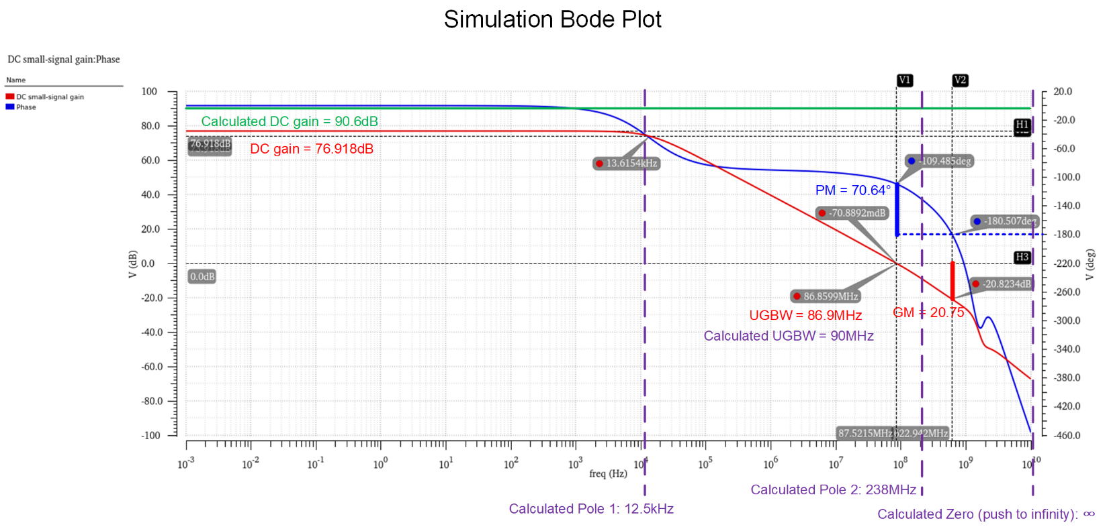
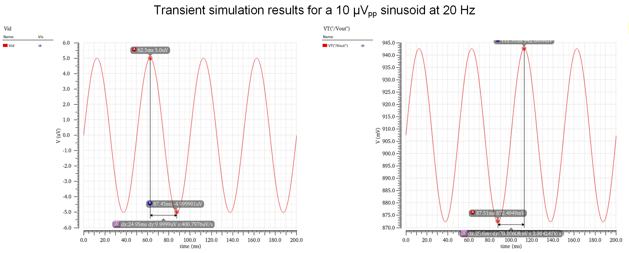

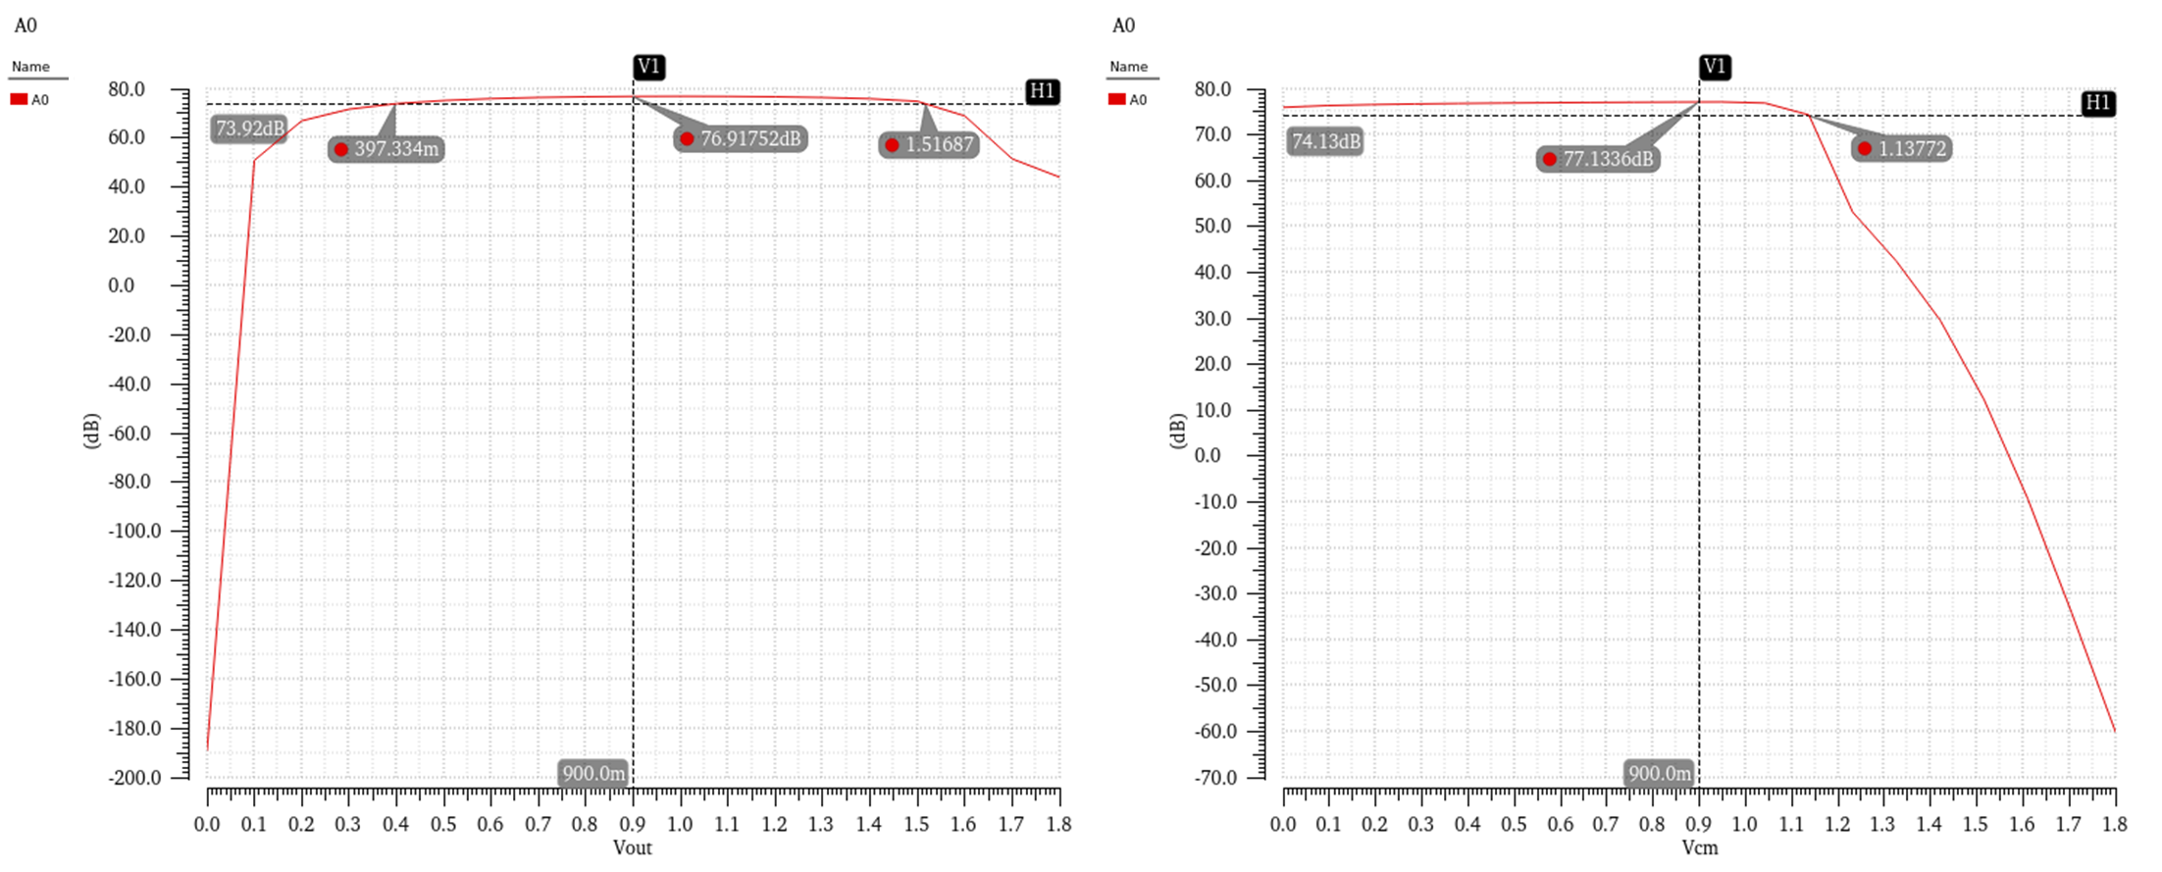
Output Common-mode Range
Input Common-mode Range

Comments and Conclusions
Finally, we completed the project and met each required specification, but at first, we used the square law to calculate everything because we did the same thing for previous homework. Right after the first simulation for those 2 amplifying stages with ideal bias, there were too many discrepancies between the hand-calculation results and SPICE model results. Therefore, we changed our strategy – using g_{m}/I_{D} method to make accurate assumptions and estimations, which decreased the workload of debugging in Cadence. However, we noticed that there are still some discrepancies between g_{m}/I_{D} and the SPICE model. The most troubling thing is the value of V_{ov} (V_{gt}), we assumed V_{ov} (V_{gt}) = 200mV but it is even below 150mV after simulation because of the discrepancy between the real BSIM model and gm/id method, which drove us crazy. At last, we learned how to do more accurate start point estimation by plotting Vgt versus gm/id to make sure the actual V_{gt} > 150mV from a selected g_{m}/I_{D}.
We also achieved significant results in power consumption optimization, with total power consumption controlled at around 1.18mW, far below the upper limit of 2.5mW.
What impressed us most in this project was the exploration and use of the g_{m}/I_{D} method. Although there is still a gap between the manual calculation results and the actual simulation results, we have deeply appreciated the superiority of this method in improving design efficiency during the project. It greatly reduces the workload of debugging parameters in Cadence, meaning that most of the time we are clear-thinking circuit design engineers rather than spice monkeys who keep tuning parameters blindly.
Furthermore, we gained a profound understanding of the nonlinearity and highly challenging trade-offs inherent in analog circuits. The design process taught us that the parameters of analog circuits are highly coupled. For example, increasing W to improve OCMR may sacrifice GBW due to increased parasitic capacitance; reducing current to lower power consumption may cause a decrease in g_{m}, thus worsening the phase margin. The design process is a continuous search for the "sweet points" of these trade-offs.
Overall, this project is a relatively complete design project that we completed after three months of studying analog integrated circuits. Compared to the lab problems in our regular assignments, the project is more systematic and tests a holistic view and overall thinking of an analog circuit design engineer, which will be very helpful for our future careers.

